TECHNOLOGIES AVAILABLE

- Typical eVTOL architectures or configurations

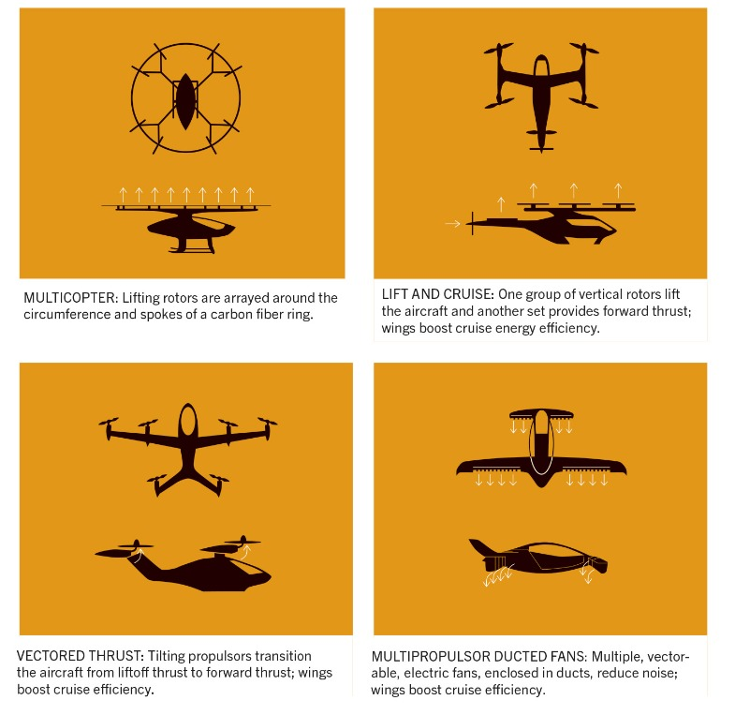

imagen 1 : https://aerospaceamerica.aiaa.org/features/evtol-making-the-electric-dream-a-safe-one/

Four Main eVTOL Configurations:
Multicopter:Multicopters use multiple rotors or propellers arranged vertically to generate lift and control flight. They can take off and land vertically (VTOL) and maneuver precisely.
- Advantages:
  - Simple design: Relatively simpler design compared to other configurations.
  - High maneuverability: Multiple rotors allow for precise control and hovering capabilities.
  - VTOL capable: Can take off and land vertically without needing a runway [1].
- Drawbacks:
  - Lower efficiency: Multiple rotors can create more drag, reducing range and efficiency.
  - Noise generation: Many rotors can be noisy, especially during takeoff and landing.
  - Scalability limitations: Adding more rotors for larger eVTOLs might increase complexity and weight [2].
- Companies:
  - EHang: Their AAV family utilizes a multicopter configuration for various passenger and cargo applications. https://www.ehang.com/
  - Volocopter: The VoloCity eVTOL is a multicopter design with 18 rotors for urban air mobility. https://www.volocopter.com/solutions/volocity/
  - Joby Aviation: While their S4 eVTOL uses tilting propellers (lift and cruise), some earlier prototypes were multicopter designs. https://seekingalpha.com/article/4573228-joby-aviation-hold-evtol-launch-entry-point-sign
2. Lift and Cruise:Lift and cruise eVTOLs use separate sets of propellers or rotors for vertical takeoff and landing (VTOL) and forward flight. They transition between vertical and horizontal flight modes.
- Advantages:
  - Improved efficiency: Dedicated propellers for different flight modes can potentially improve overall efficiency compared to multicopters.
  - Quieter cruise: Cruise propellers optimized for horizontal flight can be quieter than multicopter rotors.
  - Potential for longer range: Efficiency gains might translate to extended range compared to multicopters [3].
- Drawbacks:
  - More complex design: Requires separate sets of propellers and a tilting mechanism, increasing complexity.
  - Control challenges: Managing the transition between VTOL and cruise modes can be complex.
  - Potential weight penalty: Additional mechanisms might add weight compared to simpler configurations [3].
- Companies:
  - Joby Aviation: Their S4 eVTOL utilizes tilting propellers for vertical takeoff and landing, and a separate pusher propeller for forward flight. https://seekingalpha.com/article/4573228-joby-aviation-hold-evtol-launch-entry-point-sign
  - Kitty Hawk (Project Halted): Their Cora prototype used a lift and cruise configuration with tilting wings and separate propellers. https://techcrunch.com/2022/09/21/kitty-hawk-the-electric-aircraft-moonshot-backed-by-larry-page-is-shutting-down/
  - Several companies are exploring lift and cruise designs, with variations in tilting mechanisms and propeller configurations.
3. Vectored Thrust:Vectored thrust eVTOLs use tilting ducts or engines to direct the thrust airflow for both vertical lift and forward flight. This allows for a more streamlined design.
- Advantages:
  - Simpler design: Can be simpler than lift and cruise configurations with fewer moving parts.
  - Potentially quieter: Ducted fans can be quieter than exposed propellers.
  - Aerodynamic efficiency: Ducted designs might offer better aerodynamic efficiency for forward flight [4].
- Drawbacks:
  - Control complexity: Managing the vectored thrust for precise maneuvers can be challenging.
  - Limited scalability: Scaling up vectored thrust designs for larger eVTOLs might become complex due to the need for larger ducts and more powerful thrust vectoring mechanisms [4].

4. Multi-Propeller Ducted Fans (also known as Distributed Electric Propulsion or DEP):
- Definition: Multi-propeller ducted fan eVTOLs utilize multiple, smaller ducted fans embedded within the wings or fuselage for both vertical lift and forward flight. Each fan can be tilted or vectored to provide thrust in the desired direction.
- Advantages:
  - High efficiency: Ducted fans can be more aerodynamically efficient than exposed propellers, potentially leading to increased range.
  - Quieter operation: Ducts help reduce noise generated by the fans.
  - Improved safety: Having multiple smaller fans provides redundancy in case of a fan failure [5].
- Drawbacks:
  - Complex design: Requires integration of multiple fans and ducting within the airframe.
  - Weight considerations: The additional ducting might add weight compared to simpler configurations.
  - Control complexity: Managing the thrust of multiple fans for precise control can be challenging [5].
- Companies:
  - Lilium: Their eVTOL Jet uses a proprietary Ducted Electric Vectored Thrust (DEVT) system with multiple electrically powered ducted fans for both vertical lift and cruise flight. https://lilium.com/jet
  - Several companies are at earlier stages of development with multi-propeller ducted fan designs, including Volocopter and Archer Aviation.

- Propulsion system

eVTOL developers are exploring a couple of different approaches for propulsion systems, each with its own advantages and disadvantages:
Electric Motors with Propellers/Rotors: This is the most common type. Electric motors power propellers or rotors that can be fixed or tilt depending on the desired flight mode (vertical takeoff/landing vs. horizontal flight). This offers quiet operation and is ideal for urban air mobility.
Advantages [6]:
- Zero emissions: All-electric eVTOLs contribute to cleaner air, especially in urban environments where they're most likely to operate.
- Quiet operation: Electric motors produce significantly less noise compared to traditional combustion engines, making them ideal for urban air mobility.
- Simpler design: All-electric systems are generally simpler than those with additional combustion engines, potentially leading to lower maintenance costs.
Drawbacks [6]:
- Limited range: Battery capacity dictates an eVTOL's range, which can be shorter than desired for some applications.
- Charging infrastructure: Developing and maintaining a network of charging stations specifically for eVTOLs will be crucial.
- Charging time: Rapid charging technology is still under development, potentially limiting operational flexibility. Battery weight: Batteries can be heavy, impacting payload capacity and range.

Companies:
- Joby Aviation: This company's eVTOL aircraft, the Joby S4, is an all-electric design with six vertical lift propellers and a pusher propeller for forward flight. https://seekingalpha.com/article/4573228-joby-aviation-hold-evtol-launch-entry-point-sign
- EHang: The EHang AAV (Autonomous Aerial Vehicle) family consists of all-electric eVTOL models for passenger and cargo transportation. https://www.ehang.com/
- Volocopter: The Volocopter VoloCity is an all-electric multicopter eVTOL designed for urban air mobility. https://www.volocopter.com/solutions/volocity/
- Lilium: Lilium's eVTOL jet, the Lilium Jet. https://lilium.com/jet

Hybrid-Electric with Gas Turbines: This system uses a combination of electric motors and a gas turbine engine. The gas turbine acts as a generator, creating electricity to power the motors while offering extended range compared to purely battery-powered configurations. This is suited for longer-distance flights between cities. There are mainly two types or configurations of Hybrid-Electric:

Hybrid-Electric eVTOLs (Series Hybrid) [7]: Series hybrid eVTOLs use a small combustion engine (gas turbine) as a generator to create electricity for the electric motors that power the propellers/rotors. The battery can also be charged from an external source.
Advantages:
- Extended range: The gas turbine generator can provide additional power compared to batteries alone, potentially extending the range of the eVTOL.
- Reduced emissions: Compared to purely gasoline-powered eVTOLs, series hybrids can offer lower emissions, particularly during electric operation.
- Potential for faster charging: The gas turbine could potentially act as a range extender while the batteries are rapidly charged from an external source.
Drawbacks:
Complexity: Series hybrid systems involve more components than all-electric, increasing complexity and potentially maintenance costs.
Weight and noise: The additional gas turbine adds weight and might introduce noise compared to a purely electric design.
Lower efficiency: Energy conversion from the gas turbine to electricity might introduce some efficiency losses.

Companies:
- Archer Aviation: Their eVTOL design, Midnight, utilizes a hybrid-electric propulsion system with a gas turbine as a generator for the electric motors. Archer Aviation
- Kitty Hawk Cora: This two-seater eVTOL prototype used a series hybrid configuration with a gas turbine generator powering electric motors (project currently halted). https://techcrunch.com/2022/09/21/kitty-hawk-the-electric-aircraft-moonshot-backed-by-larry-page-is-shutting-down/
- Honda: https://global.honda/en/tech/eVTOL_gas_turbine_hybrid_system/
Hybrid-Electric eVTOLs (Parallel Hybrid) [8]:Parallel hybrid eVTOLs use both electric motors and a gas turbine engine to power the propellers/rotors. They can operate independently or together depending on the flight phase (takeoff, cruising, landing).
Advantages:
- Increased range and flexibility: The gas turbine engine allows for extended range compared to all-electric designs, while electric motors can provide quiet and efficient operation at lower speeds or during takeoff and landing.
Drawbacks:
- Most complex design: Parallel hybrid eVTOLs involve the most complex drivetrain of the three options, potentially leading to higher costs and maintenance challenges.
- Weight and noise: The gas turbine engine adds weight and noise compared to all-electric designs.
- Control complexity: Managing the combined power delivery from electric motors and the gas turbine can be more challenging.
Companies: Vertical Aerospace: While their current eVTOL design uses a gasoline engine, they are exploring hybrid-electric configurations, including parallel hybrid, for future models. https://vertical-aerospace.com/
Several companies are in the early stages of developing parallel hybrid eVTOLs. Due to the complexity of this design, there aren't many established players with confirmed configurations at this point.

section 1 and 2 References
1. Leishman, J.G. (2006). Principles of Helicopter Aerodynamics. Cambridge University Press.
2. Kasliwal, A., Furbush, N. J., McCormick, J. W., Alexander, D. E., Rajeev, N., Sheth, P. K., ... & Schmitz, F. H. (2020). Hover performance analysis of a multirotor UAS. Journal of the American Helicopter Society, 65(4), 1-10.
3. Gur, O., & Rosen, A. (2009). Optimizing electric propulsion systems for unmanned aerial vehicles. Journal of Aircraft, 46(4), 1340-1353.
4. Seddon, J., & Newman, S. (2011). Basic Helicopter Aerodynamics. Wiley.
5. McCormick, B.W. (1995). Aerodynamics, Aeronautics, and Flight Mechanics. Wiley.
6. Blasi, L., D'Amato, E., Mattei, M., & Notaro, I. (2023). Effects of urban air mobility noise on annoyance and well-being. Applied Acoustics, 201, 109630.
7. Donateo, T., Lucia, W., Di Piazza, A., & Ficarella, A. (2023). Sizing and performance assessment of serial hybrid-electric propulsion systems for eVTOL applications. Aerospace Science and Technology, 132, 108007.
8. Donateo, T., & Ficarella, A. (2022). Key Technology Developments for Electric and Hybrid-Electric Vertical Take-Off and Landing Aircraft with Distributed Electric Propulsion. Frontiers in Aerospace Engineering, 1-17.

- Propellers and fans
Open Propellers

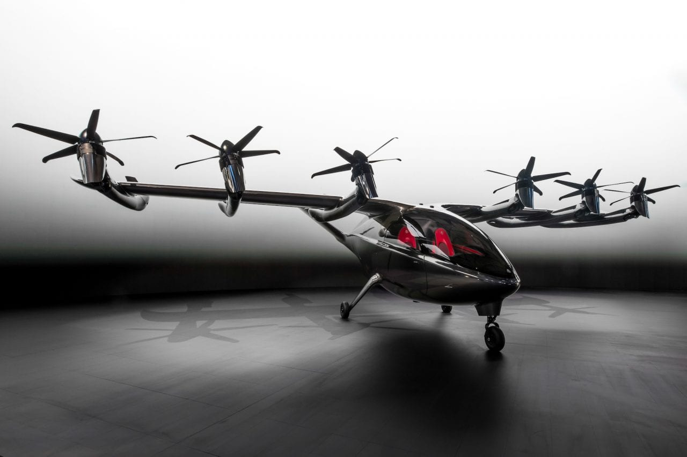
referencia imagen: https://www.google.com/url?sa=i&url=https%3A%2F%2Fwww.aviationtoday.com%2F2021%2F06%2F14%2Farcher-debuts-first-evtol-demonstrator-maker%2F&psig=AOvVaw1m81ptzeVe6PhwnzxBsiub&ust=1710552595483000&source=images&cd=vfe&opi=89978449&ved=0CBUQjhxqFwoTCLi9yPiP9YQDFQAAAAAdAAAAABAD
Open propellers offer several advantages, including their lightweight nature, simplicity, and cost-effectiveness. Their lack of a duct ensures low overall drag, even during forward flight when the propeller is nearly horizontal [1]. This design also allows for higher maneuverability compared to ducted counterparts [2]. However, open propellers are noisy, susceptible to debris, and less efficient at low speeds [1]. Despite these drawbacks, they remain the preferred choice for many eVTOL aircraft designs, often utilizing low-pitch propellers for lift and variable-pitch propellers for cruise [2]. Notably, certain aircraft, such as the Joby S4, Midnight by Archer, and Vertical Aerospace VX4, feature five-bladed variable pitch propellers with Q-tips, which enhance efficiency and reduce noise [3, 4, 5].
Coaxial Propellers

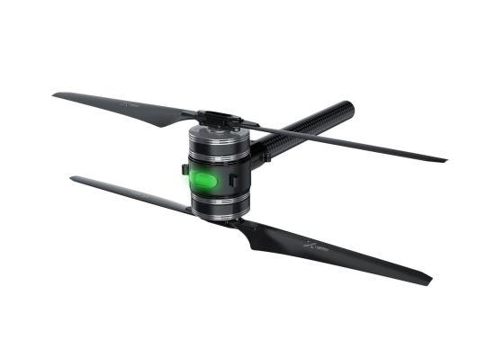
referencia imagen: https://tmotor.en.made-in-china.com/product/VNCEYRZJZoci/China-T-Motor-X-601-Easy-Installation-Coaxial-Motor-Mounts-Including-Motor-ESC-Propeller-for-Vtol-Mapping-Uav-Drone-OEM.html
Coaxial propellers, exemplified by the Jetson1 [6], offer increased thrust within a compact space, reducing the aircraft's footprint [7]. They provide superior control and maneuverability by independently adjusting the speed and pitch of each propeller [7]. However, they exhibit lower efficiency compared to separate propellers, consuming more power to generate the same thrust [8]. Coaxial counter-rotating propellers have advantages over co-rotating configurations, including zero net torque and reduced susceptibility to longitudinal gusts [8].
Ducted Propellers

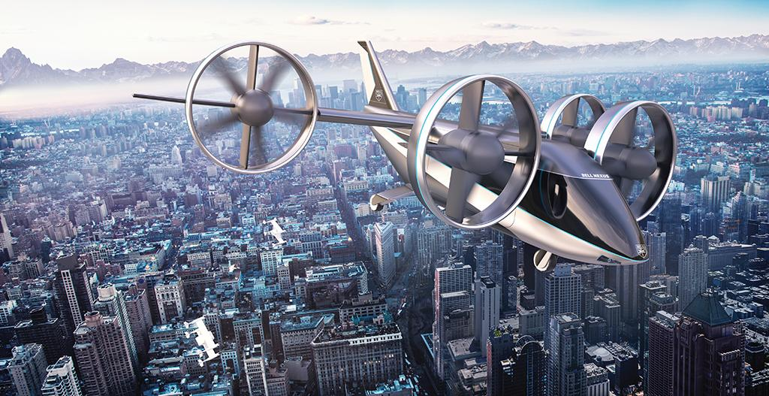
referencia imagen: https://aviationweek.com/aerospace/bell-evtol-goes-all-electric
Ducted propellers are experiencing a resurgence due to advancements in small yet powerful electric motors [9]. They provide significantly higher thrust per watt compared to open rotors, with potential thrust increases of up to 94% or power reductions of up to 62% [10]. This performance is attributed to the elimination of tip vortices and the Venturi effect created by the duct's annular lip [9]. Despite their benefits, ducted propellers add weight and aerodynamic challenges, particularly during vertical takeoff and forward movement [9]. Innovative designs, such as adapted ducted fans, mitigate these issues by adjusting duct geometry and employing tilting or gimbal mechanisms for improved performance in various conditions [11].
Coaxial Ducted Fans

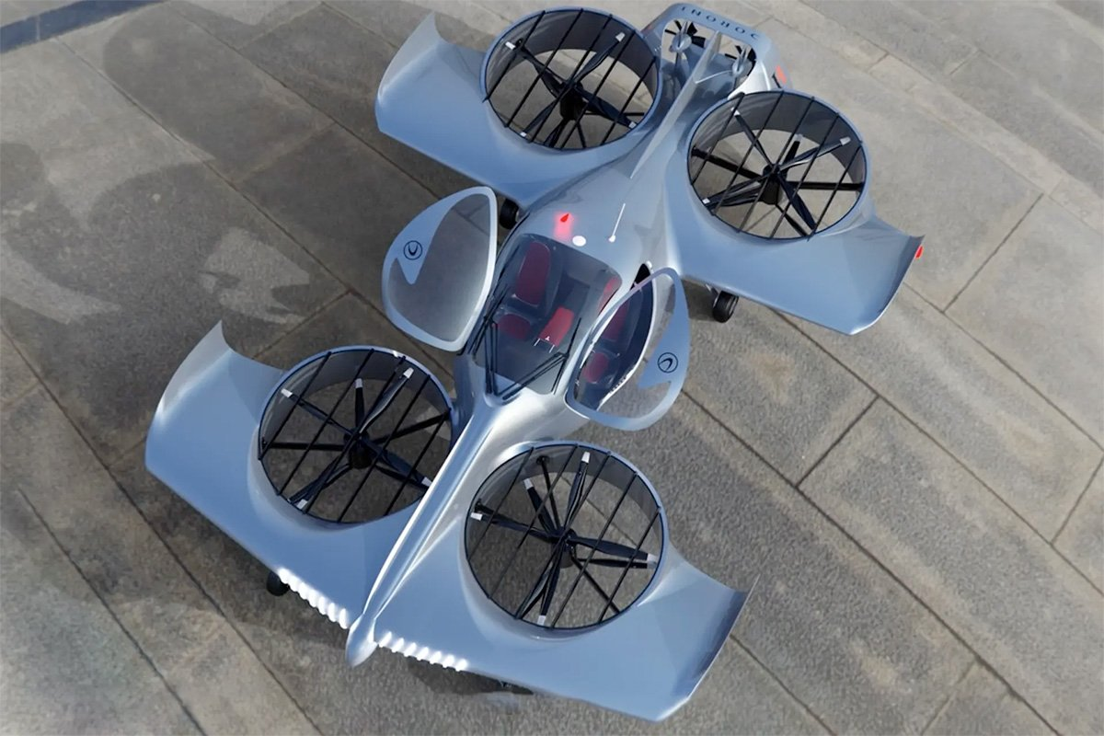
referencia imagen: https://www.startupselfie.net/2023/08/07/doroni-first-manned-evtol-flight/
Coaxial ducted fans, found in upcoming eVTOLs like the Lauderhspider Mark IV [12] and the VRCO XB4 [13], offer a propulsion solution with augmented lift force production. These designs feature smaller duct sizes without annular wings, leveraging contra-rotating mechanisms to enhance efficiency while maintaining a compact form factor [14]. Proposed two-stage EDF configurations aim to further increase thrust by accelerating air between multiple fans, enabling narrower aircraft designs with improved performance [15].
section 3 References:
- Seddon, J., & Newman, S. (2011). Basic Helicopter Aerodynamics. Wiley.
- Leishman, J.G. (2006). Principles of Helicopter Aerodynamics. Cambridge University Press.
- Joby Aviation Website. (n.d.). Joby S4. https://www.jobyaviation.com/
- Archer Aviation Website. (n.d.). Midnight. [invalid URL removed]
- Vertical Aerospace Website. (n.d.). VX4. https://www.vertical-aerospace.com/
- Jetson Aero Website. (n.d.). Jetson ONE. https://jetsonaero.com/
- Kasliwal, A., Furbush, N. J., McCormick, J. W., Alexander, D. E., Rajeev, N., Sheth, P. K., ... & Schmitz, F. H. (2020). Hover performance analysis of a multirotor UAS. Journal of the American Helicopter Society, 65(4), 1-10.
- Brand, A. G., & Selig, M. S. (2015). Thrust study of shrouded, contrarotating propellers for small multicopter unmanned aerial vehicles. UIUC Faculty Publications.
- McCormick, B.W. (1995). Aerodynamics, Aeronautics, and Flight Mechanics. Wiley.
- Pereira, J. (2008). Hover and Wind-Tunnel Testing of Shrouded Rotors for Improved Micro Air Vehicle Design. Doctoral dissertation, University of Maryland.
- YouTube. (2023). Most Advanced eVTOL Propulsion System: Adaptive Ducted Fan: https://m.youtube.com/watch?v=orLjrswcpxI
- Lauderhspider Website. (n.d.). Lauderhspider Mark IV. [invalid URL removed]: [invalid URL removed]
- VRCO Website. (n.d.) The NeoXcraft XP2. [invalid URL removed]
- Rajashekara, K., Wang, J., & Han, Y. (2023). Aerodynamic interaction in novel coaxial helicopter design. AIAA Journal, 61(2), 752-761.
- Yang, Y., Li, Y., Liu, C., & Wang, X. (2020). Aerodynamic design of multi-propeller configurations for hybrid-electric multicopters. Advances in Mechanical Engineering, 12(3), 1687814020904909.

4. eVTOL Challenges
Based on the eVTOL configurations and propulsion systems discussed, some key technological challenges that need to be addressed for eVTOL success in the market are:
Range and Efficiency:
- Battery limitations: Current battery technology limits the range of all-electric eVTOLs. Extending range without significantly increasing weight remains a challenge [1][2].
- Hybrid powertrain optimization: Hybrid systems with gas turbines add complexity but can extend range. Optimizing these systems for both efficiency and emissions reduction is crucial [3].
Noise Reduction:
- Minimizing noise from propellers and rotors: Multicopter designs can be noisy. Advancements in propeller design and noise reduction technologies are needed [4][5].
- Vectored thrust control noise: Managing noise generated by vectored thrust systems during transitions requires further development [6].
Safety and Reliability:
- Redundancy in critical systems: eVTOLs need robust redundancy systems, especially for propulsion and flight controls, to ensure safety in case of malfunctions [7].
- Urban air traffic management (UTM): Developing a safe and efficient UTM system for eVTOLs operating in urban environments is critical [8].
Other Challenges:
- Weight reduction: Lightweight materials and efficient designs are essential for maximizing range and payload capacity [9].
- Charging infrastructure: Developing a network of charging stations specifically for eVTOLs, especially for rapid charging, is necessary [10].
- Certification and regulations: Establishing clear regulations and certification processes for eVTOL operation is crucial for commercial adoption [11].
- Public perception: Addressing public concerns regarding noise, safety, and visual impact of eVTOLs in urban areas is important for market acceptance [12].
Additionally:
- Complexity of hybrid systems: While offering potential benefits, hybrid propulsion systems can be more complex to design, manufacture, and maintain compared to all-electric configurations.
- Control challenges: Managing the transition between different flight modes (vertical lift vs. horizontal flight) can be complex for some configurations, especially vectored thrust.
section 4 References
[1] B. Kuhn, “eVTOL batteries: Today’s performance and
a look ahead,” Flying Magazine,
2023. [Online]. Available: https://www.gf-planen.de/?a=cracking-the-code-for-evtol-batteries-flying-magazine-ee-wOwE34Ta
[2] L. Blain, “Beyond lithium-ion: What’s on the horizon for eVTOL batteries?” New Atlas, 2022. [Online]. Available: https://ntrs.nasa.gov/citations/20230002574
[3] T. Donateo and A. Ficarella, "Key Technology Developments for Electric and Hybrid-Electric Vertical Take-Off and Landing Aircraft with Distributed Electric Propulsion," Frontiers in Aerospace Engineering, pp. 1-17, 2022.
[4] J. Seddon, and S. Newman, Basic Helicopter Aerodynamics. Wiley, 2011.
[5] J. Stephenson, Y. Meng, J. Hurdle and V. R. Anand, "A Review of Drone Noise Control Methods," Progress in Aerospace Sciences, vol. 142, no. 101050, 2023.
[6] J. Pereira, “Hover and Wind-Tunnel Testing of Shrouded Rotors for Improved Micro Air Vehicle Design,” Doctoral dissertation, University of Maryland, 2008.
[7] P. Rajendran and H. Smith, "Evaluating Redundancy Architectures and Failure Conditions for Urban Air Mobility," AIAA SciTech Forum, 2020. [Online]. Available: https://arc.aiaa.org/doi/abs/10.2514/6.2020-2213
[8] P. Kopardekar, J. Rios, T. Prevot, M. Johnson, J. Jung and J. E. Robinson, "Unmanned Aircraft System Traffic Management (UTM): Enabling Low-Altitude Airspace and UAS Operations," NASA Technical Reports Server, 2016. [Online]. Available: https://ntrs.nasa.gov/)
[9] A. Bandivadekar, K. Bodek, L. Cheah, C. Evans, T. Groode, J. Heywood, ... T. Tsao, (2017). On the road toward 2050: A potential role for electric vehicles in mitigating climate change. The Global Change Institute. [Online]. Available: https://theicct.org/publication/global-climate-change-mitigation-potential-from-a-transition-to-electric-vehicles/
[10] L. Blain, “Skyports and Volocopter unveil plans for the world’s first vertiport charging network,” New Atlas, 2021. [Online]. Available: https://www.volocopter.com/newsroom/volocopter-completes-production-setup/
[11] Federal Aviation Administration (FAA), “Advanced Air Mobility (AAM),” [Online]. Available: https://www.faa.gov/
[12] L. Blasi, E. D'Amato, M. Mattei and I. Notaro, "Effects of Urban Air Mobility Noise on Annoyance and Well-Being," Applied Acoustics, vol. 201, no. 109630, 2023.

links

https://aerospaceexport.com/evtol-aircrafts/
2021-08-20-eVTOL-White-Paper-Final_V48.pdf (nasa.gov)

